Accompanying Notes for Teachers WATP Stage 2 Physics:

Please complete the blanks on Page 2 of the paper for Marks removed etc

Students will need a copy of the WATP Formula and Constants sheet for Stage 2 Physics. A number of calculations require that they obtain data from this sheet.

Students will need a copy of a periodic table with element names for the 2A/2B exam

A high quality Periodic Table can be downloaded by schools free of charge from the Jefferson Lab education site.

http://education.jlab.org/itselemental/

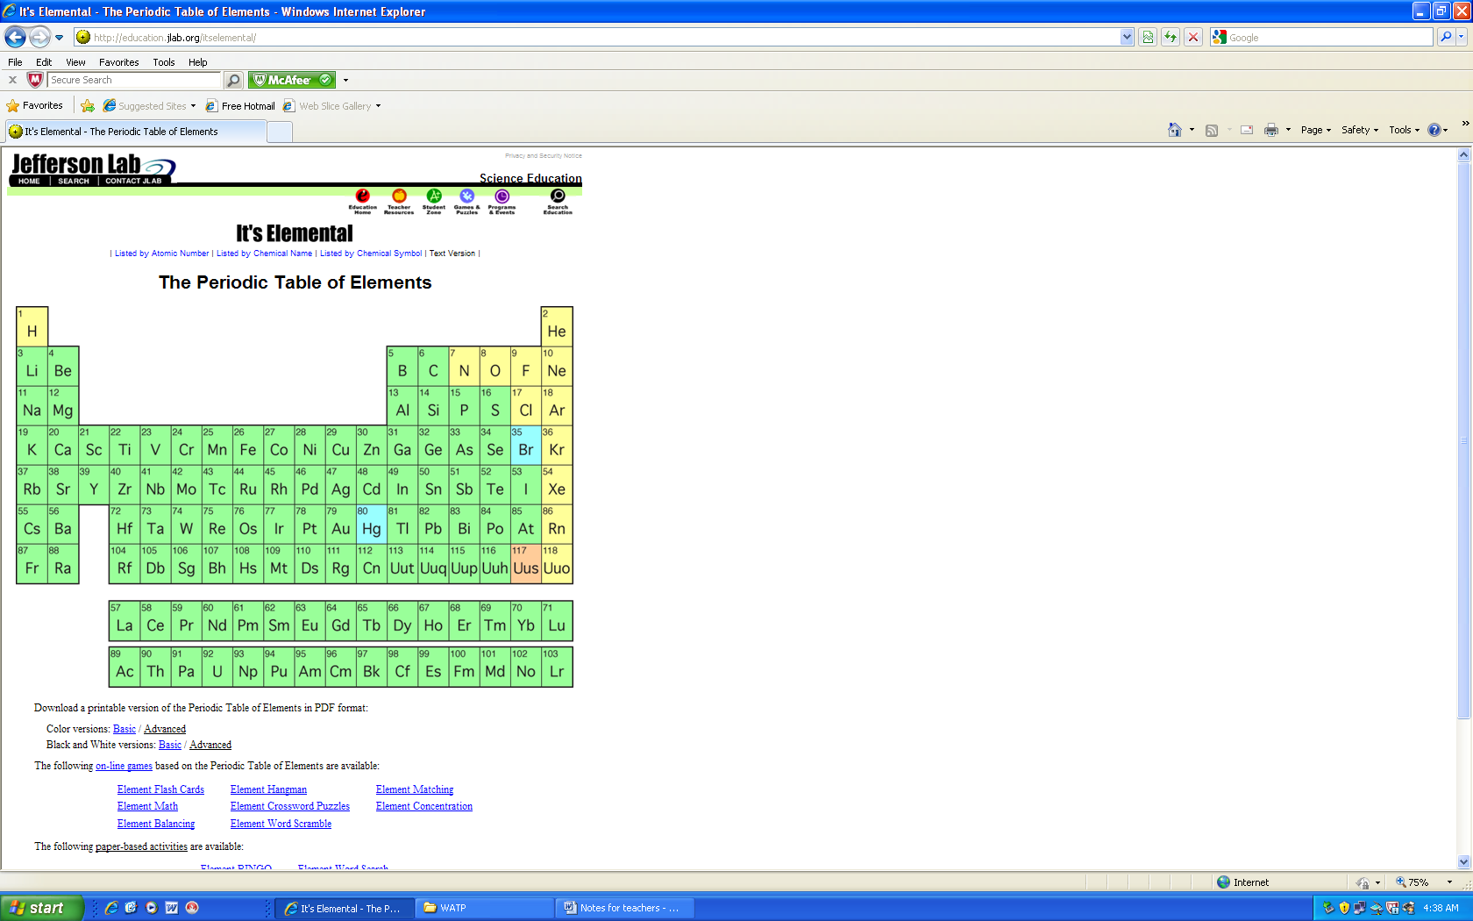
Select the advanced version to download as a pdf either in colour or black and white.

